


Police Department Update

Barry Fox Chief of Police
City of St. Augustine

City Commission Meeting October 26, 2020

- Uniform Crime Statistics

16,000
14,000
12,000
10,000
8,000
6,000
4,000
2,000
0

Population vs. Crime Rate - 20 Year

Population

Crime Rate

2000 2005 2010 2015 2019
Police Department Update

- Uniform Crime Statistics
Total Index Crimes - 20 Year
1200

1000

800

600

400
Total Index Crime

Police Department Update
200

0
2000 2005 2010 2015 2016 2017 2018 2019

- Uniform Crime Statistics

1000
Police Department Update
900
800
700
600
500
400
300
200
100
0

2010 2011 2012 2013 2014 2015 2016 2017 2018 2019 2020
Semi Annual
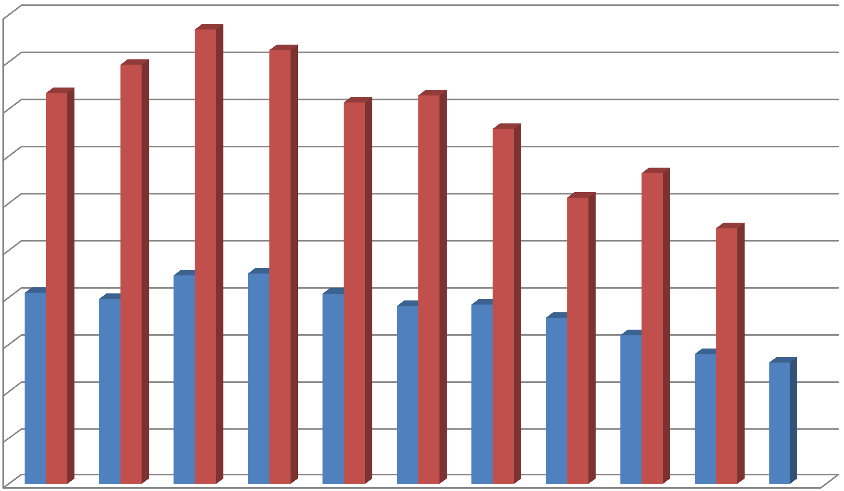
Annual

Homeless Outreach

St. Francis Housing Crisis Center

  - Partnership with St. Francis House continues with the rental of 8 beds
    - 2019:
      - 233 individuals were referred to the St. Francis House Crisis Center.
  - SAPD Quality of Life Program:
    - 6 households were identified and were assisted with the installation of wrap around services.
      - 5 individuals
      - 1 married couple

Homeless Outreach

Family Reunification Program

- Family Reunification:
  - 146 individuals were reunited with family members willing to assist in taking them off the streets.
- Rehab / Detox:
  - 20 individuals were placed into a rehab or detox based upon counseling by the Outreach Officers or court related instructions.
- Care Connect:
  - All individuals continue to be connected with services.

Commission for Florida Law Enforcement Accreditation

CFA

- 239 Standards to be met
  - Each Standard has one or more proofs
- Mock Assessments:
  - 1st – November 18-20, 2020
  - 2nd – January 19-21, 2021
- Final On-Site Assessment:
  - April 13-15, 2021

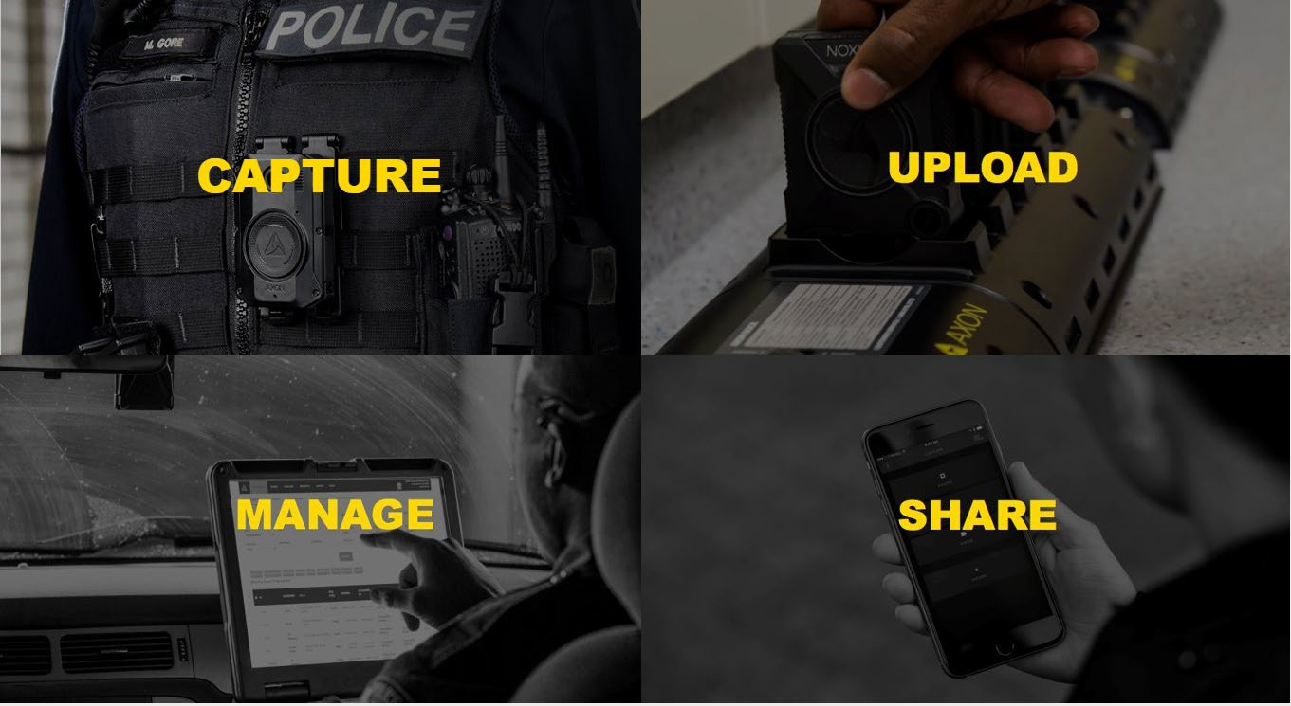
Body Cameras

A contract with Axon Enterprise, Inc. has been signed for Body Cameras and Tasers Cameras have been received and training has begun
- Annual cost of
$152,387
  - Less than our initial estimate of
$200,000
per year

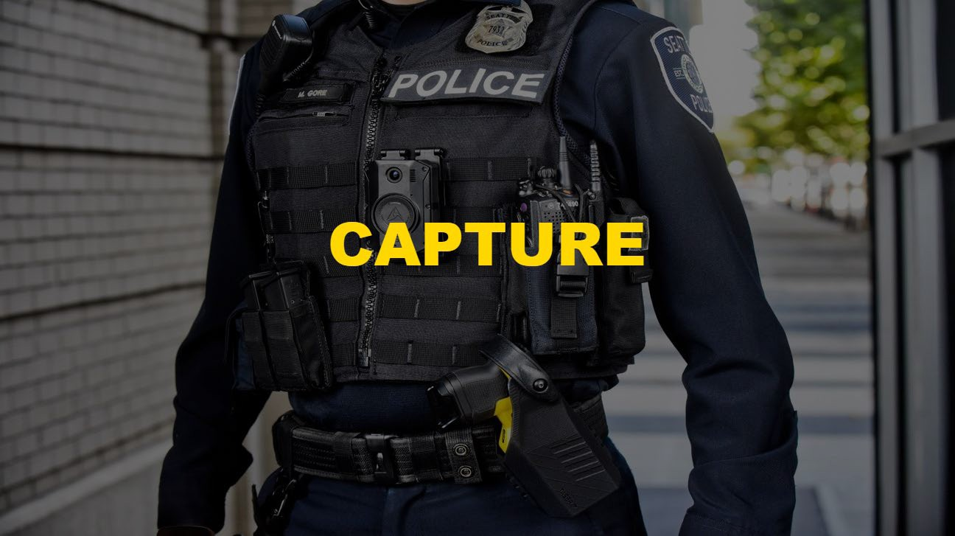
Body Cameras-The Axon Body 3

- Full Shift Battery, 12+ Hours
- Versatile & Stable Mounts
- Human Field of View
- Configurable Pre-Event Buffer
- Automatic & Manual Activation
- Guaranteed Upgrades

Body Cameras-Axon Signal

Connects the camera to the Car, the Taser and the Sidearm
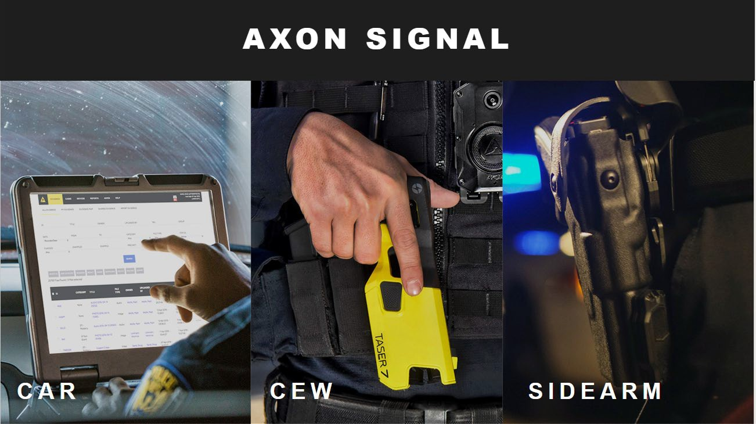

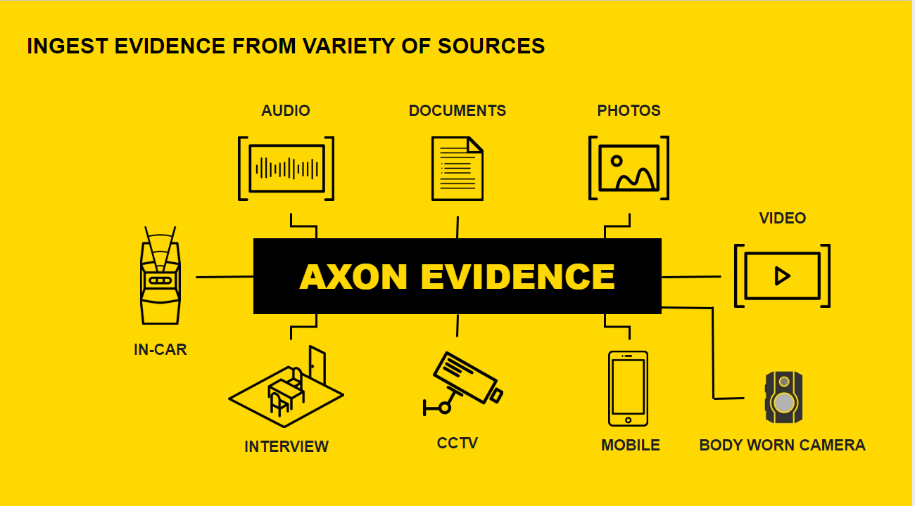
Body Cameras-Upload, Manage & Share

  - Officers dock cameras after each shift for: Automatic Upload, Automatic Charging, Firmware Updates, Device Monitoring

Body Cameras-Automatic and Manual Redaction

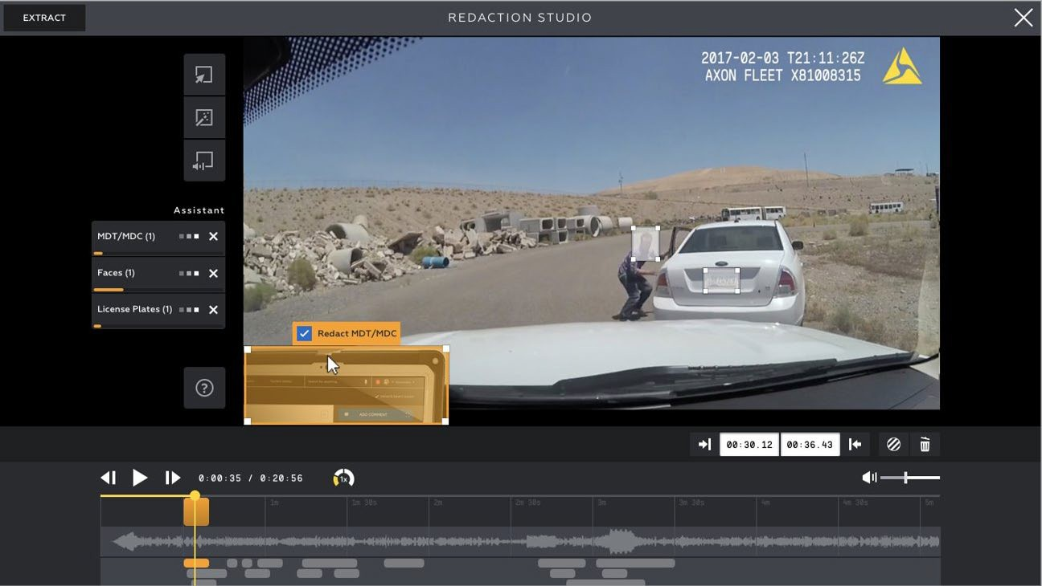

Questions? Thank you!



