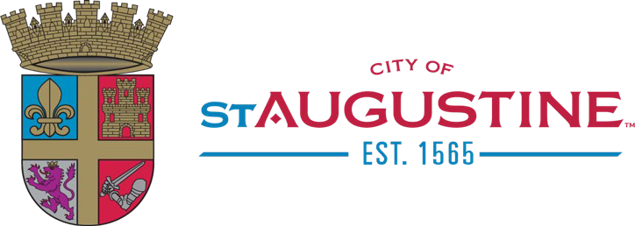
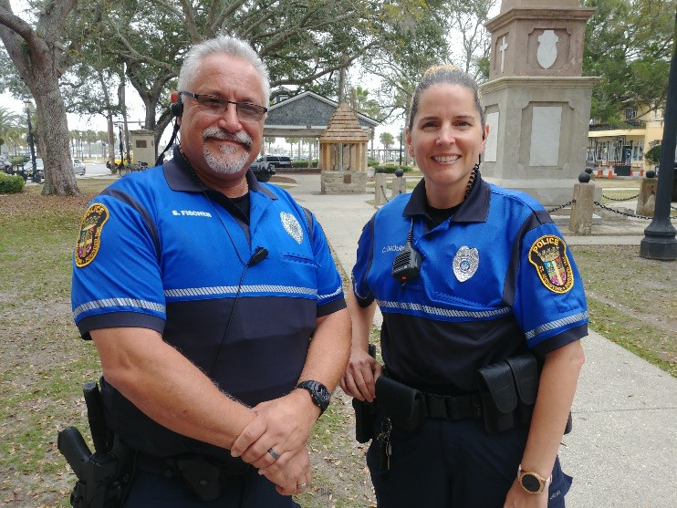
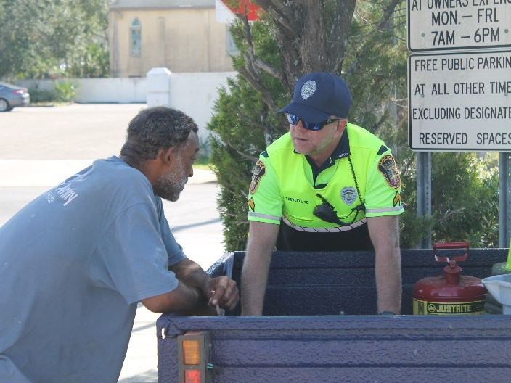
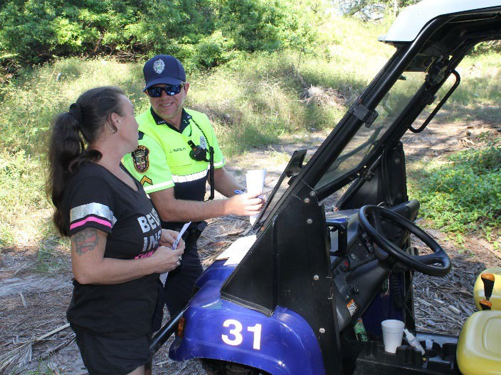
HOMELESSNESS IN ST. AUGUSTINE

Homelessness
According to City Code, homelessness is defined by one’s nighttime residence, such as 1) a supervised shelter designed to provide temporary living accommodations, 2) an institution that provides a temporary residence for
individuals intended to be institutionalized; or 3) a public or private place not designed for, or ordinarily used as, regular sleeping accommodations for human beings.
In these cases, welfare hotels, congregate shelters, transitional housing for those with mental illness, or temporary housing for individuals intended to be institutionalized, would fit that definition.
(Ord. No. 07-03, & 1, 3-12-07.)

Homelessness vs. Panhandling
Panhandling is a separate issue from homelessness; and, therefore has its own restrictions. While some panhandlers are homeless and some homeless engage in panhandling, the two terms are not interchangeable.
Homelessness is the condition of those who do not have a permanent dwelling, such as a house or apartment.
Panhandling is begging for money with a dependence on the sympathy of others.
While panhandling may be a crime, homelessness is not.

Where can the homeless find a place to go?
City Code dictates that between the hours of 10:00pm and 6:00am, sleeping, camping and habitation is prohibited; however, enforcement of these ordinances is dependent on the availability of facilities, to which the City of St. Augustine has limited access.
To allow for a place to sleep overnight, the City funds beds at the St. Francis House and to allow for restroom use, the City opens, maintains, and monitors several public restroom locations around the city at all times.
During daytime hours when residents and visitors are faced with the visible reality of our homeless condition in historic downtown areas, there is a sense of urgency to remove these people from their places on the sidewalks. But it is not illegal for a person to sit or lie in a public space as log as there is room for pedestrians and wheelchairs to pass and no entrances are blocked.

St. Augustine Police Department | Community Outreach Program | 904.825.1074 | citypolice@staugpd.com

HOMELESSNESS IN ST. AUGUSTINE
Since the implementation of the SAPD Community Outreach Unit in 2018,
there has been a dramatic improvement in the City of St. Augustine’s impact on managing homelessness.


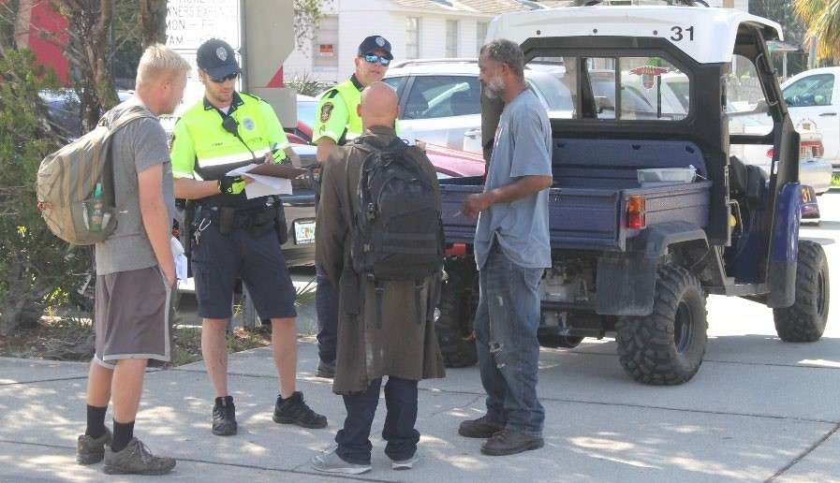
Strategic Plan – Compassion & Support
In the 2018 Strategic Plan, the City of St. Augustine set an objective of providing resources for the homeless to ensure that all are afforded the basic necessities of life. This is a
long-term commitment that includes offering compassion and support to our homeless population and treating all with dignity and respect, while providing continuous
education and recognition of the unique needs of our homeless population.

SAPD Community Outreach Unit
The St. Augustine Police Department is committed to
identifying our City's vulnerable homeless residents and ensuring that they are offered and receive resources that are available to them through the Community Outreach Unit. This unit, established in December 2018, focuses on community outreach by building positive connections with our homeless population. These officers personally reach out to homeless residents, discover what the individual
needs, and offer corresponding resources. These resources may include admission to the Family
Reunification Program, a referral to Flagler Health Plus- Care Connect, or providing other services.

City of St. Augustine - Family Reunification Program If a person qualifies for the Family Reunification Program, Community Outreach Unit Officers will confirm that the individual has relatives or friends able to assist him or her outside of St. Augustine and help the individual travel
there by issuing a bus pass. An individual is only able to enter this program once.

Flagler Health Plus - Care Connect Program
Care Connect, a Flagler Health Plus program, connects an individual with a case worker, who will then provide them with needed services, like assistance with filing or
obtaining paperwork, medical or mental health services, housing assistance, clothing vouchers, and so on. The
Community Resource Officers will continue to provide aid by following up with the individual and the case worker, as well as give rides to follow up appointments.

Other Services
- Rides to and from appointments with doctors, Social Security Office, Care Connect, and job interviews.
- Clothing vouchers for Alpha Omega Thrift Store
- Roadside counseling
- First aid for minor injuries
- Attend first appearance at Court House, as needed
- Work with both the State and City Attorney’s Offices
- Collaborate with local Veterans Affairs Office
- Attend and participate in St. Johns County Drug Court
- Create and maintain the Habitual Offender’s List
- Assist individuals in obtaining a PO Box
How do SAPD Community Outreach Officers impact our homeless population? *As of January 21, 2020

Number Helped | Services Provided directly by Community Outreach Officers
233 | Referred to St. Francis House
146 | Family Reunification Program
13 | Sentenced to rehab through the Habitual Off Program
7 | On-Street Counseling / Placed in rehab on voluntary basis
6 | Provided services to at-risk residents so they could age in place in their own homes
3 | Rehoused through other community partners

Number Helped | Services provided by Community Outreach Officers in conjunction with Flagler Health Plus - Care Connect
55 | Total referrals by Community Outreach Officers
18 | Individuals transitioned out of homelessness
18 | Housed
15 | Currently helping
11 | Medical needs identified and met
10 | Referred for food stamps
9 | Provided transportation assistance
5 | Engaged in housing program

Financial commitment of SAPD:
2 additional patrol officers $140,000
Funding beds at St. Francis House $100,000 Family Reunification Program $25,000
Total investment $265,000

