City of St. Augustine Boundary

COSA Boundary ±

National Geographic, Esri, Garmin, HERE, UNEP-WCMC, USGS, NASA, ESA, METI, NRCAN, GEBCO,

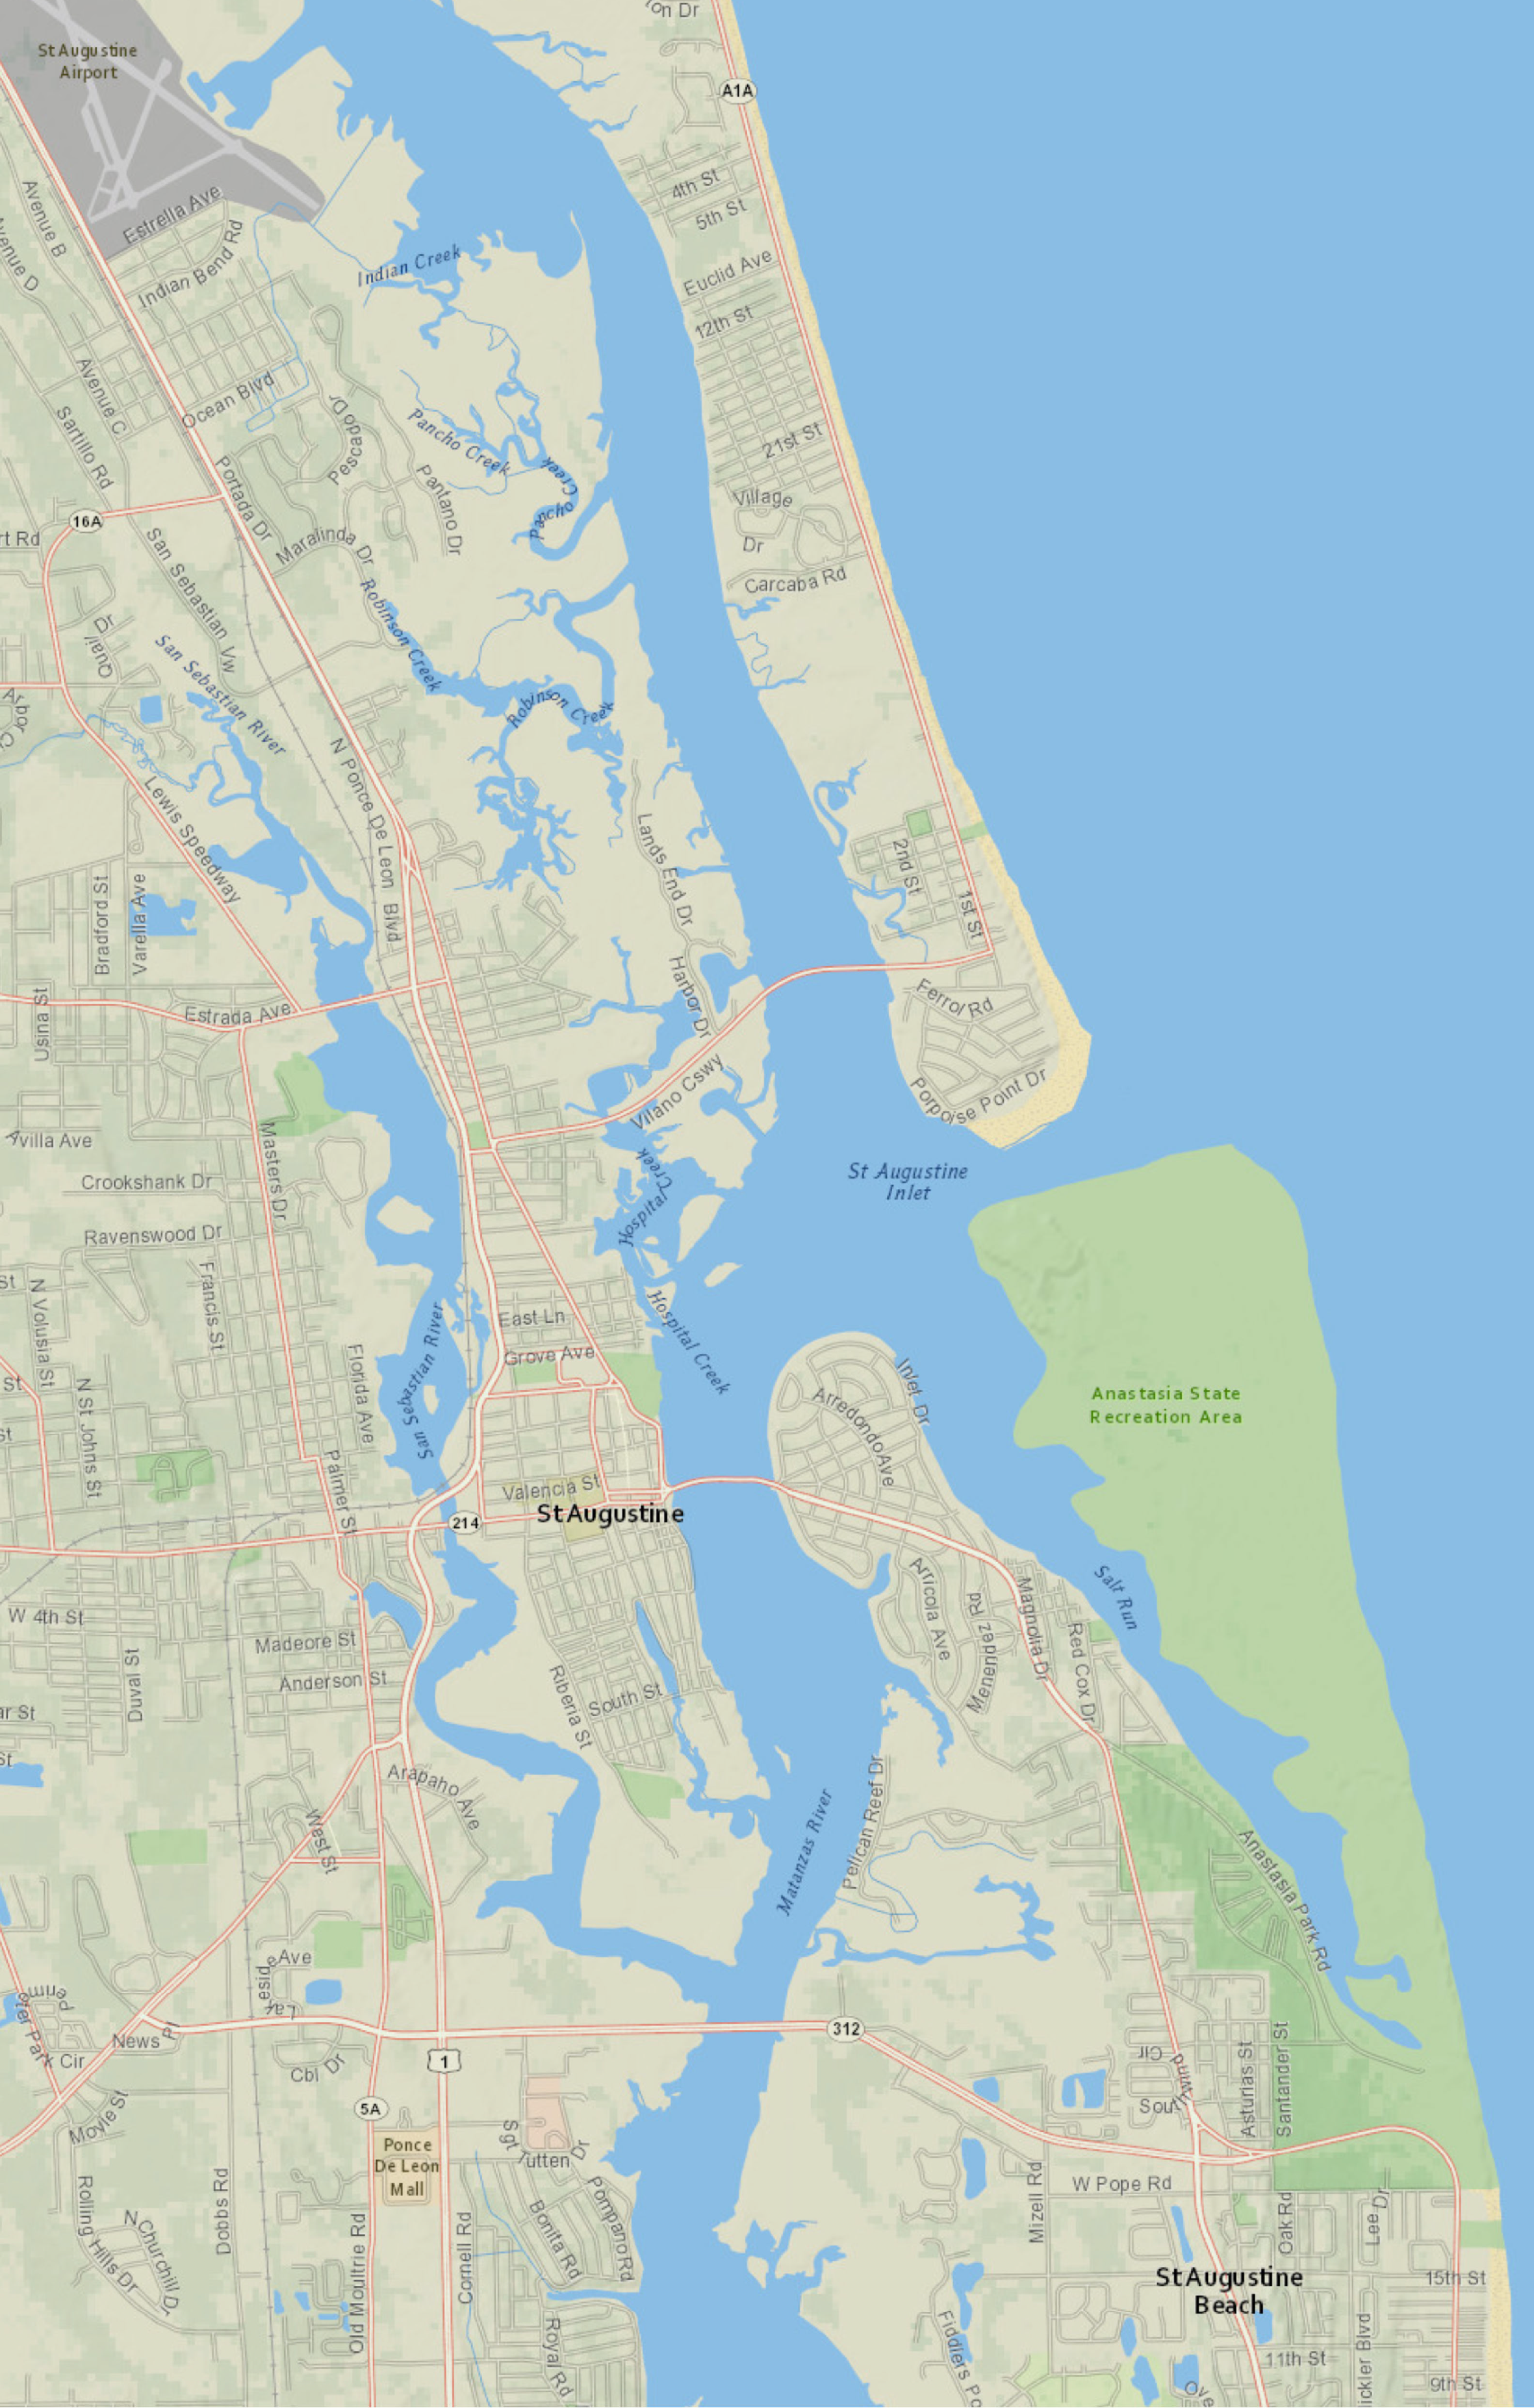
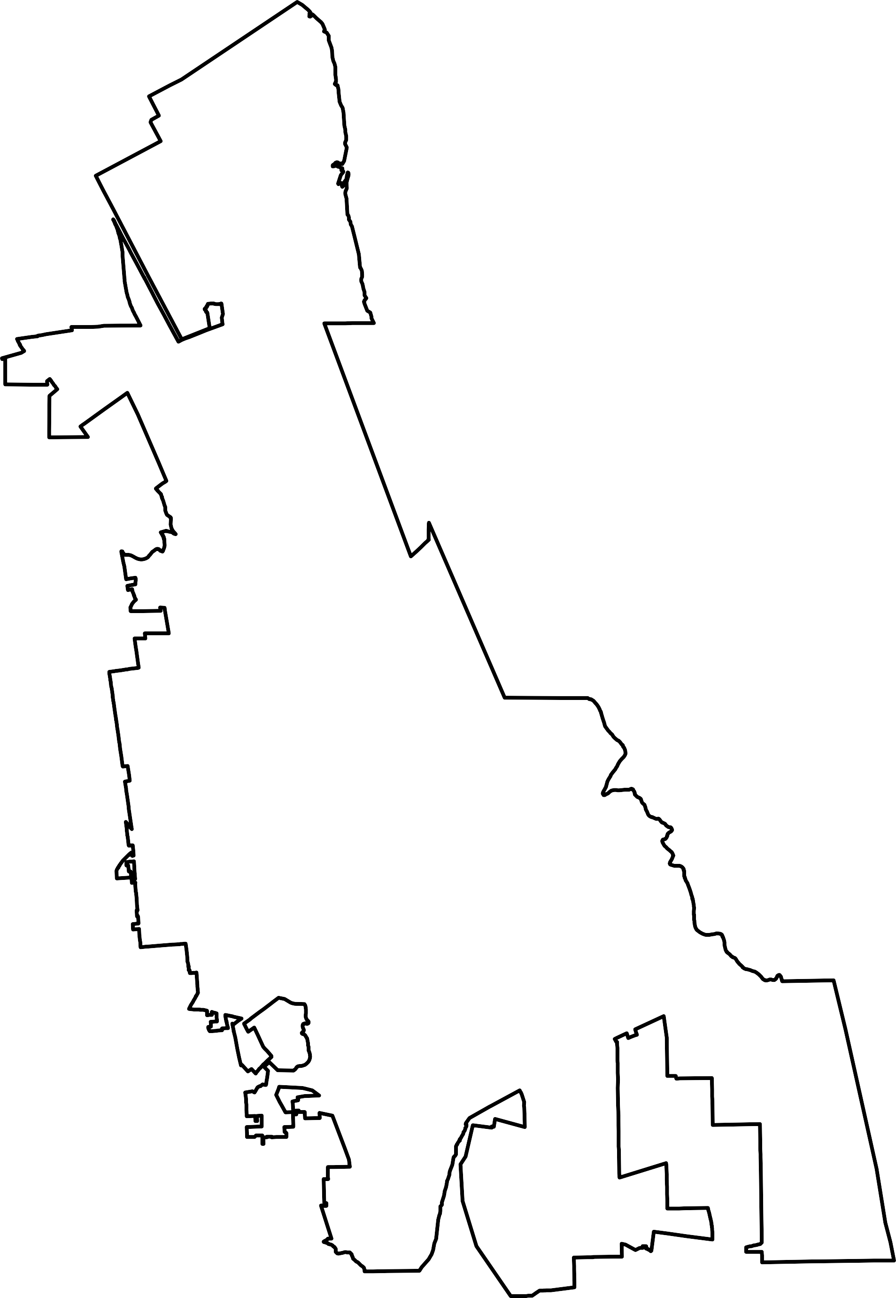

0 0.5 1 Miles
NOAA, increment P Corp.

