
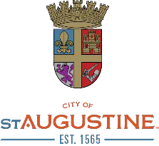
BEGGING, PANHANDLING, AND SOLICITATION
SEC. 18-8 OF THE CODE OF THE CITY OF ST. AUGUSTINE

INTENT OF ORDINANCE
- To recognize, but not limit the constitutional right of a person to solicit, panhandle or beg in a peaceful and non-threatening manner.

- To acknowledge the increase in aggressive panhandling and begging throughout the City that has become disturbing and disruptive to residents and businesses.

- To prohibit aggressive panhandling and to enforce distance based regulations to designate restricted areas in which panhandling and begging are not permitted.

- To protect the health, safety, and welfare of the citizens of and visitors to the City of St. Augustine.

PROHIBITED CONDUCT

Aggressive Panhandling or Begging:
  - To approach or speak to a person in order to demand, request, or beg for money or a donation of valuable property in a way that would cause a reasonable person to believe they are being threatened with imminent bodily injury or that a crime is going to be committed upon themselves, someone in their company, or property in their possession. This includes a panhandler placing themselves within 2 feet of a solicited person and/or using abusive or profane language in a loud voice.

  - To maintain contact with a solicited person, by walking in front of, next to, or behind them, while continuing to demand, request, or beg for money or a donation of valuable property after the solicited person has refused or said “no”.

  - To obstruct, block, or impede the passage or free movement of a solicited person or someone in their company by walking, standing, sitting, laying or placing an object in their path that would require them to take evasive action. This includes, but is not limited to, persons traveling on foot, bicycle, wheelchair, operating a motor vehicle, or getting in or out of a motor vehicle.

  - To touch or make physical contact with a solicited person or someone in their company or to touch their vehicle without their consent.

  - To engage in behavior intended to intimidate, compel, or force a solicited person to give in to the panhandler’s demands.

PROHIBITED AREAS

It shall be unlawful to panhandle or beg:

Within 20 feet, in any direction, from any entrance or exit of commercially zoned property.

  - Within 20 feet, in any direction, from any entrance or exit of any bus or trolley stop or any public transportation facility.

  - Within 20 feet, in any direction, from an ATM or any electronic information device that accepts or dispenses cash in connection with an account with a financial institution.

  - Within 20 feet, in any direction, of any parking lot, garage, meter, or pay station owned or operated by the City.

  - Within 20 feet in any direction, of any public restroom owned and operated by a governmental agency.

  - Within 100 feet, in any direction, of any daycare or school, including pre-kindergarten through grade 12.


PROHIBITED AREAS (cont.)

It shall be unlawful to panhandle or beg:

At any outdoor dining area
  - At any outdoor merchandise area
  - At any transit stop or taxi stand
  - Inside any public transit vehicle
  - By approaching the operator or occupant of a motor vehicle
  - By approaching a person waiting in line to be admitted to a commercial establishment
  - In any area after dark or while under the influence of drugs and/or alcohol

    - Panhandling or begging of any kind, not just aggressive, is unlawful in all Prohibited Areas listed herein.


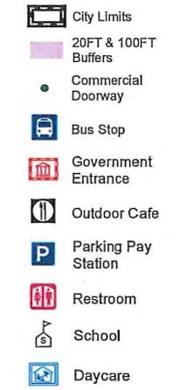
SAMPLE MAPS OF PROHIBITED AREAS

Sample Maps are provided herein to show areas where panhandling or begging is not permitted.
Map Key

      - Sample Maps provided encompass portions of the Historic District and San Marco Avenue.

COMPLETE MAPS SHOWING ALL PROHIBITED AREAS WITHIN THE CITY LIMITS OF THE CITY OF ST. AUGUSTINE ALONG WITH THE FULL TEXT OF ORDINANCE 2018-06 ARE AVAILABLE TO VIEW ON THE CITY’S WEBSITE AT:

http://www.citystaug.com/panhandle/

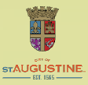

HISTORIC DISTRICT – 1

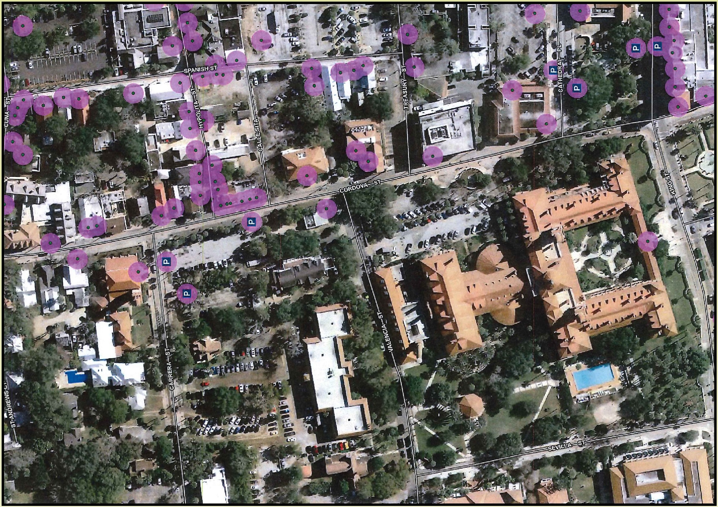

HISTORIC DISTRICT - 2

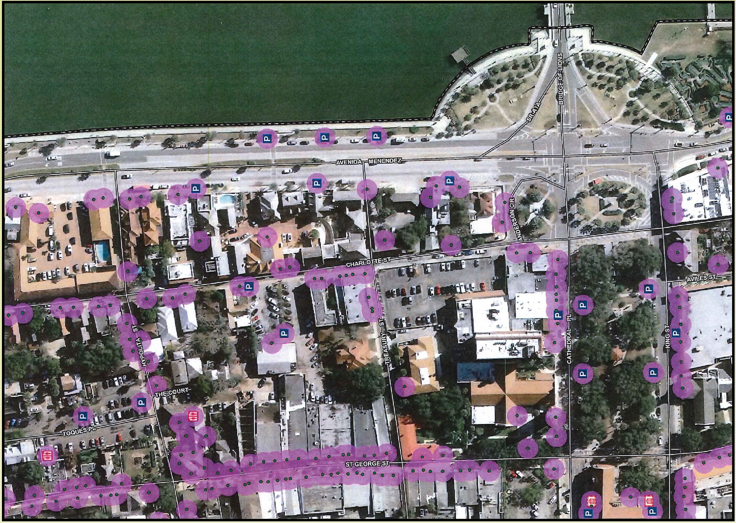

HISTORIC DISTRICT - 3

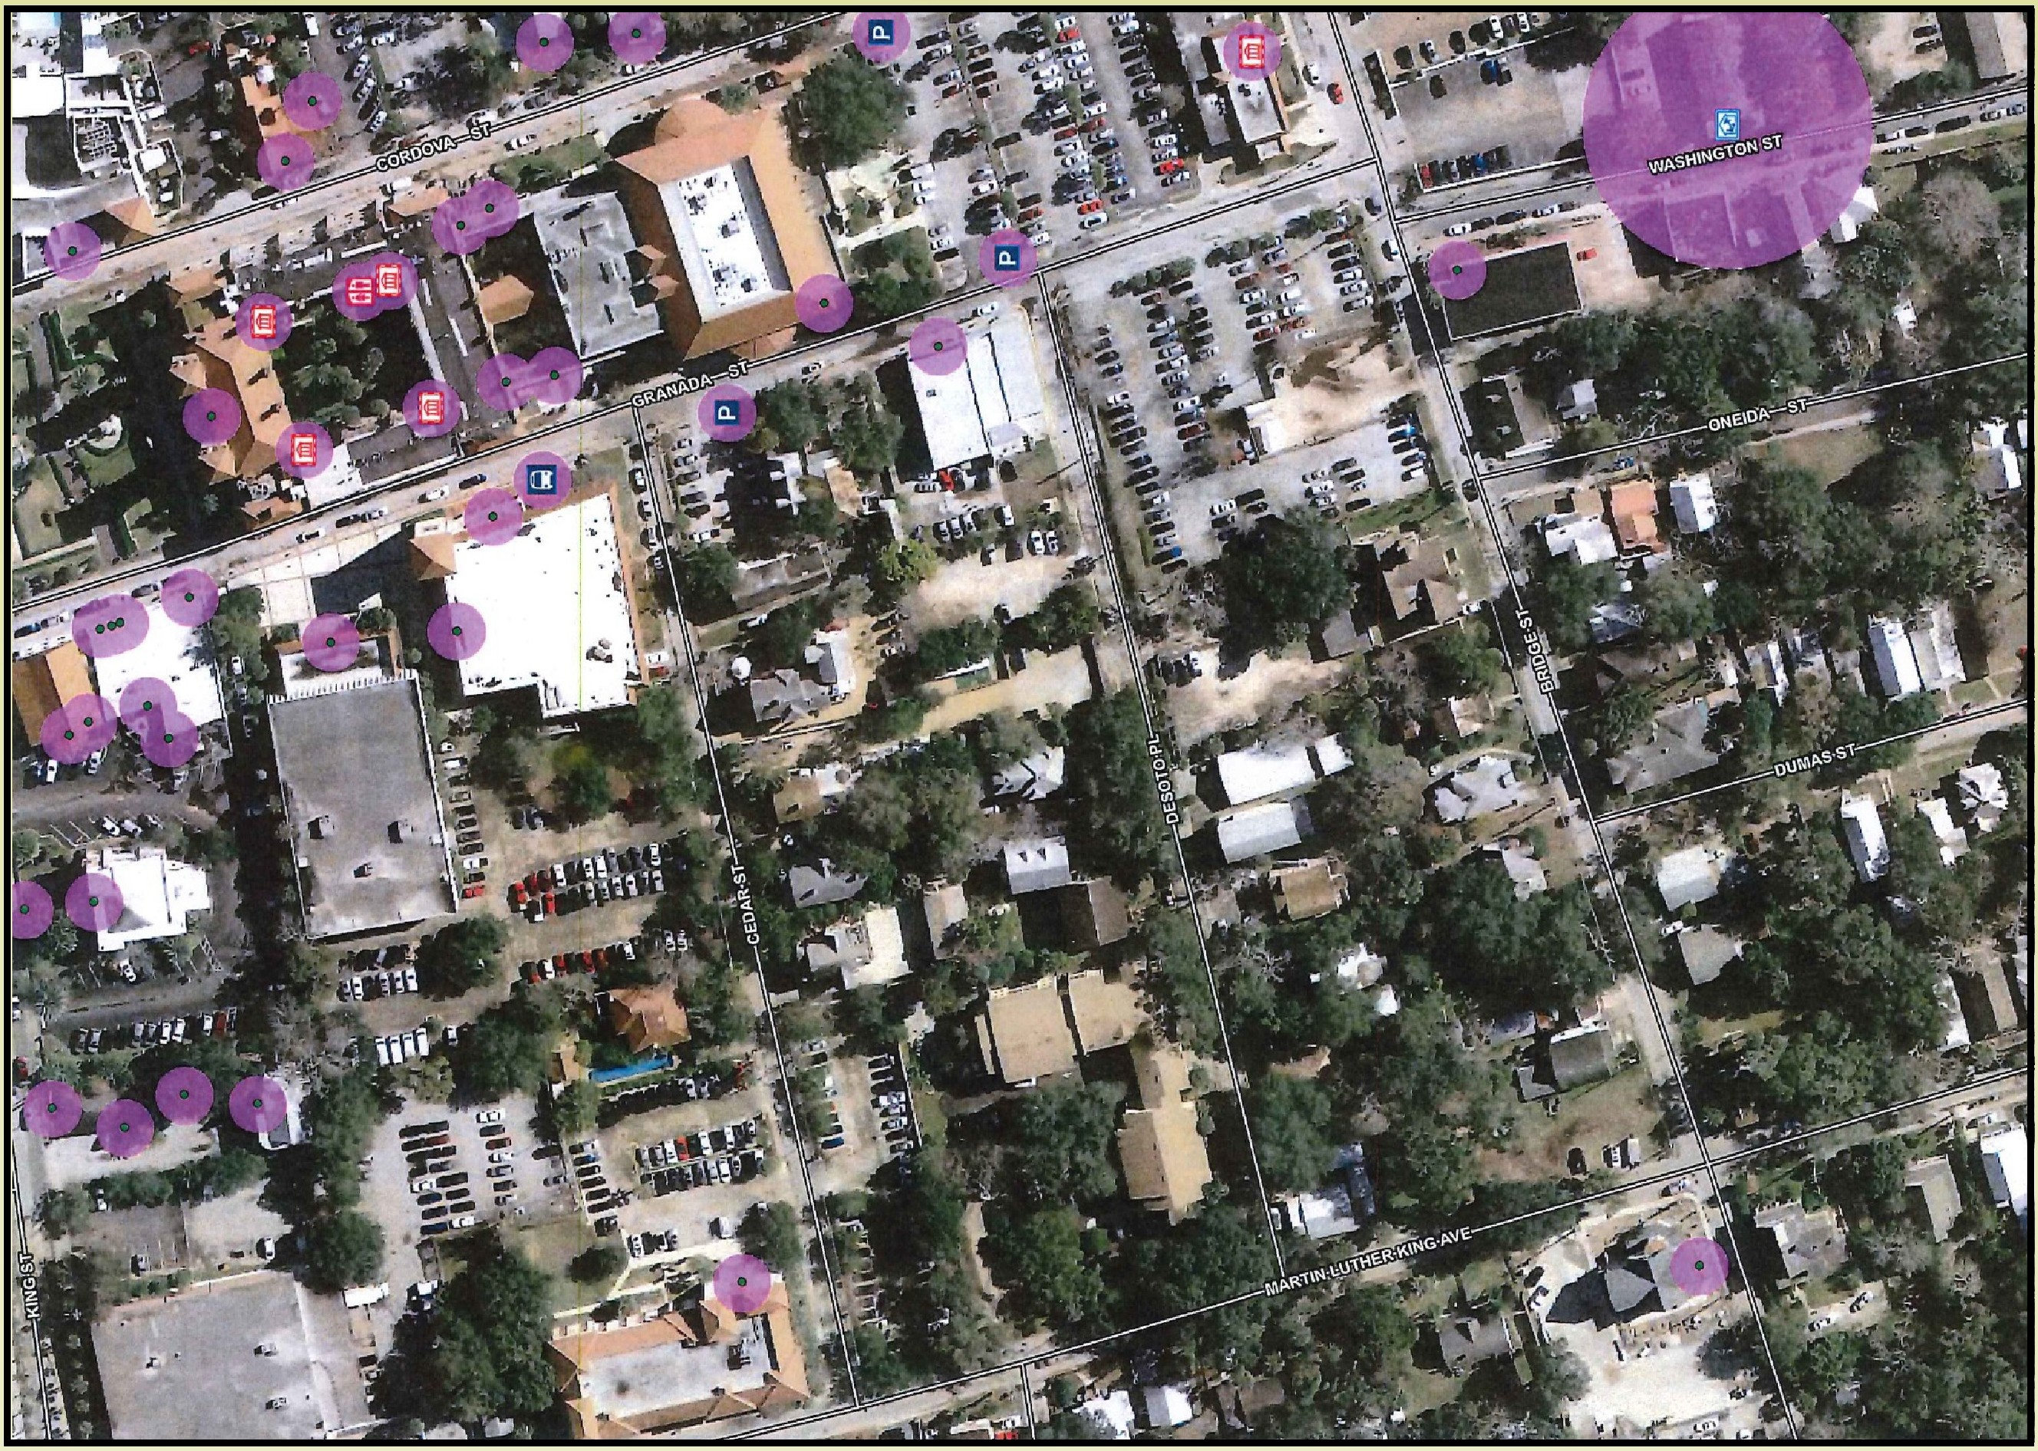

SAN MARCO AVENUE - 1

SAN MARCO AVENUE - 2
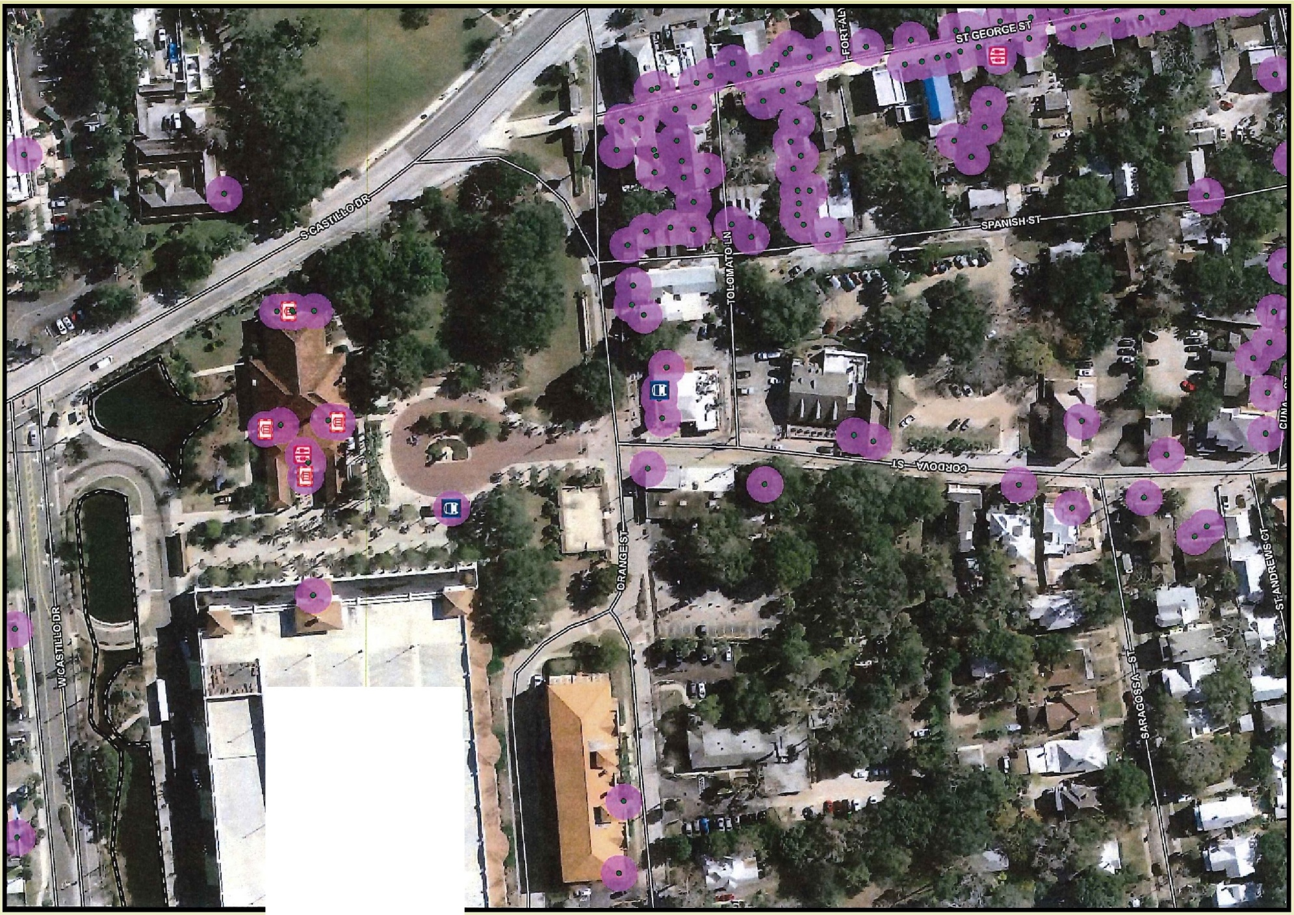

. . T •

w "':'_• _ - --- - .:- ..- - - ---- -- -

.- .• - - -
i
,- /.I,
/

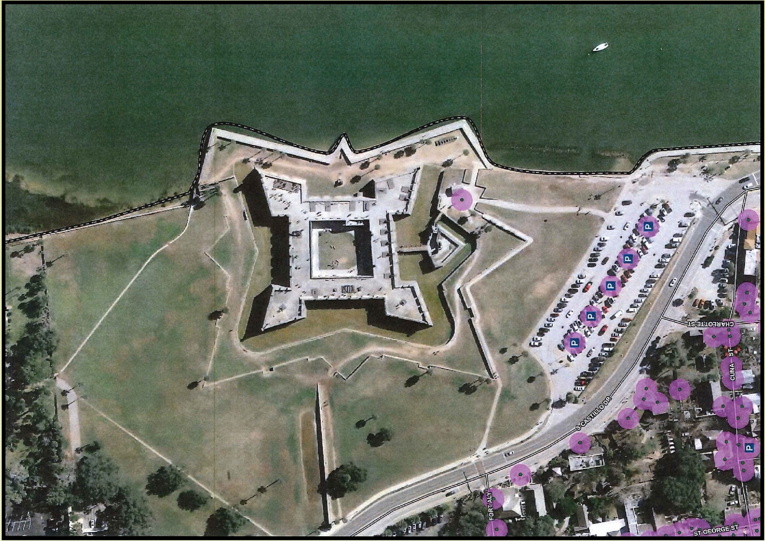
SAN MARCO AVENUE - 3

