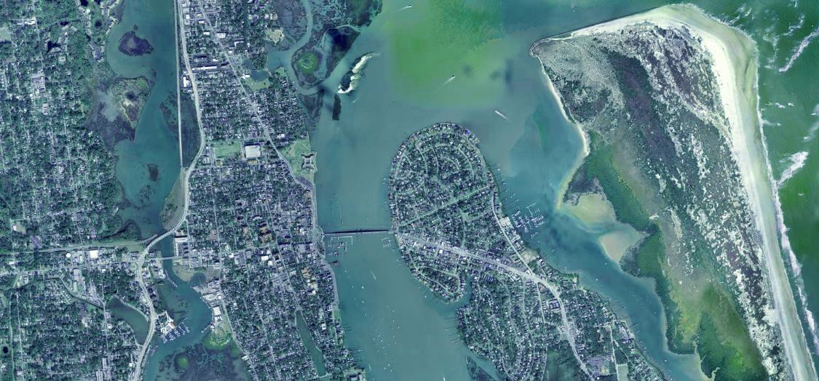


FUNDING SOURCES AND
LEGAL ASPECTS:
Isabelle Lopez
City Attorney


FUNDING SOURCES:
- AD VALOREM TAXATION
- NEIGHBORHOOD OR BUSINESS IMPROVEMENT DISTRICT
- SPECIAL ASSESSMENTS
- LOCAL DISCRETIONARY TAX
- GRANTS
- AD VALOREM: Broad source of revenue based on property taxes can be used for any public project.
- DISTRICTS: §163.511 Ad valorem tax via referendum specific to district only, up to maximum of 2 mills, includes drainage and street improvements.
- SPECIAL ASSESSMENTS: Drainage, Seawalls, Streets. Not a tax, no limits, but must pass 2-prong test:
The property assessed must gain a special benefit The assessment must be apportioned equitably.

- LOCAL DISCRETIONARY TAX:
New option per §125.0104 tourist development tax now includes build/repair/improve public facilities needed to increase tourist-related business activities (includes transportation, drainage, pedestrian).

- GRANTS: FEMA Hazard Mitigation, EPA Smart Growth. http://toolkit.climate.gov/content/funding-opportunities
58

FUNDING SOURCES:
  - IMPACT FEE/MOBILITY FEE
  - USER FEE
  - TRANSFER OF DEVELOPMENT RIGHTS (TDRS)
  - COMMUNITY DEVELOPMENT DISTRICT (CDD)
  - HOMEOWNERS ASSOCIATION
  - COMMUNITY REDEVELOPMENT AGENCY (CRA)


- IMPACT FEE: Reflect cost of adaptation infrastructure that services new development; mobility fees designed with level of service (LOS) that factors adaptation retrofits.

- USER FEE: Utilities pass on the costs of maintaining the system, stormwater utility fees can fund the adaptation capital costs of providing the service to the end user.

- TDRS: Allow density on vulnerable properties to be transferred to other parcels; “sending” “receiving”.

- CDDS: Form of government, can factor costs of resiliency into capital improvements specific to it.

- HOAS: §336.125 Transfer public roads to private HOA within residential subdivisions, may be favored if community control over level and cost of adaptation.

- CRAS: Captures increase in property taxes (TIF) and sets it aside for capital projects to improve “blight” (includes inadequate street layout & unsafe conditions).
59

FUNDING SOURCES:
- PUBLIC-PRIVATE PARTNERSHIP (§287.05712)
- MUNICIPAL BOND
- GOVERNMENT RISK FINANCING

- P3: Contract between public & private entity providing for private funding of infrastructure in exchange for revenue sharing (toll roads, parking structures).
- MUNICIPAL BONDS:
- General Obligation Bond: Full faith & credit, voter approved;
- Ad Valorem Bond: Secured by proceeds of ad valorem taxes, voter approved;
- Revenue Bond: Payable from revenues not ad valorem (utility fees, impact/mobility fees, parking fees);
- Improvement Bond: payable from special assessments for the project.
- GOVERNMENT RISK FINANCING:
- Catastrophe (Cat) Bond: Insurance co. issues bond through bank, investors buy bond, if no catastrophe in set period, insurance co. pays investors, FEMA launched 1st cat bond to transfer risk of NFIP in 2018.
- Parametric Hurricane Policy: Does not indemnify pure loss but agrees to payment if set metric is reached
60
(wind speeds), Alabama obtained 1st state parametric hurricane policy in 2010.

A WORD ON THE BERT J. HARRIS ACT (§70.001)…

(10)(a) This section does not apply to any actions taken by a governmental entity which relate to the operation, maintenance, or expansion of transportation facilities, and this section does not affect existing law regarding eminent domain relating to transportation.
- (b) This section does not apply to any actions taken by a county with respect to the adoption of a Flood Insurance Rate Map issued by the Federal Emergency Management Agency for the purpose of participating in the National Flood Insurance Program, unless such adoption incorrectly applies an aspect of the Flood Insurance Rate Map to the property in such a way as to, but not limited to, incorrectly assess the elevation of the property. Question: could this include freeboard rule, or other local code created mitigation as part of NFIP community?

Beware of Jordan v. St. Johns County (5th DCA 2011) (not Bert Harris but inv. condemnation; failure to either maintain or abandon road in light of changing environmental conditions). Question: could adaptation area plus adopted LOS
have solved the government’s dilemma? 61

