RESOLUTION NO. 95-24

A RESOLUTION OF THE CITY COMMISSION OF THE CITY OF ST. AUGUSTINE, FLORIDA, RELATING TO ACCESS TO LOCAL PUBLIC OFFICIALS; PROVIDING A MEANS FOR THE PUBLIC TO CONFER WITH LOCAL OFFICIALS ON AN EX PARTE BASIS; PROVIDING A REQUIREMENT FOR DISCLOSURE OF EX PARTE COMMUNICATIONS; CREATING A REQUIREMENT THAT RECORDS OF EX PARTE COMMUNICATIONS BE RETAINED BY THE CITY CLERK; AND PROVIDING AN EFFECTIVE DATE

WHEREAS, the principles of democratic government have always allowed the public to have access to their elected and appointed officials; and
WHEREAS, several decisions of appellate courts within this State have impeded the public’s right of access to elected and appointed officials in the exercise of their quasi-judicial functions; and
WHEREAS, the State Legislature has adopted Section 286.0115, Florida Statutes, providing a means whereby local governments can restore the public’s access to local government officials through the adoption of a resolution;
NOW, THEREFORE, be it resolved by the City Commission of the City of St. Augustine, Florida, that:

Section 1. The City Commission of the City of St. Augustine, Florida, pursuant to the authority set forth in Section 286.0115, Florida Statutes, hereby adopts the following procedures with the intention of removing the presumption of prejudice from ex parte communications with local public officials by establishing a process to disclose ex parte communications with such officials.
(a) The procedures adopted herein shall be applicable to all local public officials, which shall include the City Commission and all elected or appointed board members serving on any City board or panel while acting in a quasi-judicial capacity, including, but not limited to, the Planning and Zoning Board; Municipal Code Enforcement Board; Historic Architectural Review Board; Board of Adjustments and Appeals; Civil Service Board; Police Officers Retirement System Board of Trustees; Firefighters’ Pension Trust Fund Board of Trustees; and City Employees’ Retirement System Board of Trustees.
(b) Any person not otherwise prohibited by statute, charter provision or ordinance may discuss with any local public official the merits of any matter on which action may be taken by any board or commission on which the local public official is a member.
(c) The substance of any ex parte communication with a local public official, whether oral or in writing, which relates to a quasi-judicial action pending before the official is not presumed prejudicial to the action if the subject of the communication and the identity of the person, group or entity with whom the communication took place is disclosed and made a part of the record before final action on the matter.
(d) A local public official may read a written communication from any person, group or entity. However, a written communication that relates to a quasi-judicial action pending before a local public official or board shall not be presumed prejudicial to the action if such written communication is made a part of the record before final action on the matter.
(e) Local public officials may conduct investigations and site visits and may receive expert opinions regarding quasi-judicial actions pending before them. Such activities shall not be presumed prejudicial to the action if the existence of the investigation, site visit or expert opinion is made a part of the record before final action on the matter.
(f) Disclosure of written or oral ex parte communications or of the existence of any investigations or site visits by local public officials and any expert opinions reviewed by local public officials regarding quasi-judicial matters shall be publicly disclosed before or during the public meeting at which a vote is to be taken on such matters, in order that persons who have opinions contrary to those expressed in the ex parte communication are given a reasonable opportunity to refute or respond to the communication. If the ex parte communication was an oral communication, the commissioner or board member may orally report the subject of communication and identity of the person, group or entity with whom the oral communication took place. If the ex parte communication was in writing, the written documents shall be provided to the Clerk before or during the public hearing, and the Clerk, commissioner or board member shall orally announce to the public a summary of the contents of the written record and the identity of the person, group or entity providing the communication. Such written record shall be retained by the Clerk as part of the minutes of the meeting.
(g) In addition to oral disclosure of the subject of ex parte communications, the commissioner or board member may submit, as part of the record, a written summary of the communication which shall be filed with the Clerk and included in the minutes of such meeting.

Section 2. This Resolution shall take effect immediately upon its adoption.

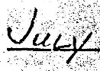
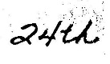
ADOPTED in Regular Session of the City Commission of the City of St. Augustine, Florida, this _________ day of _________________________, A.D., 1995.
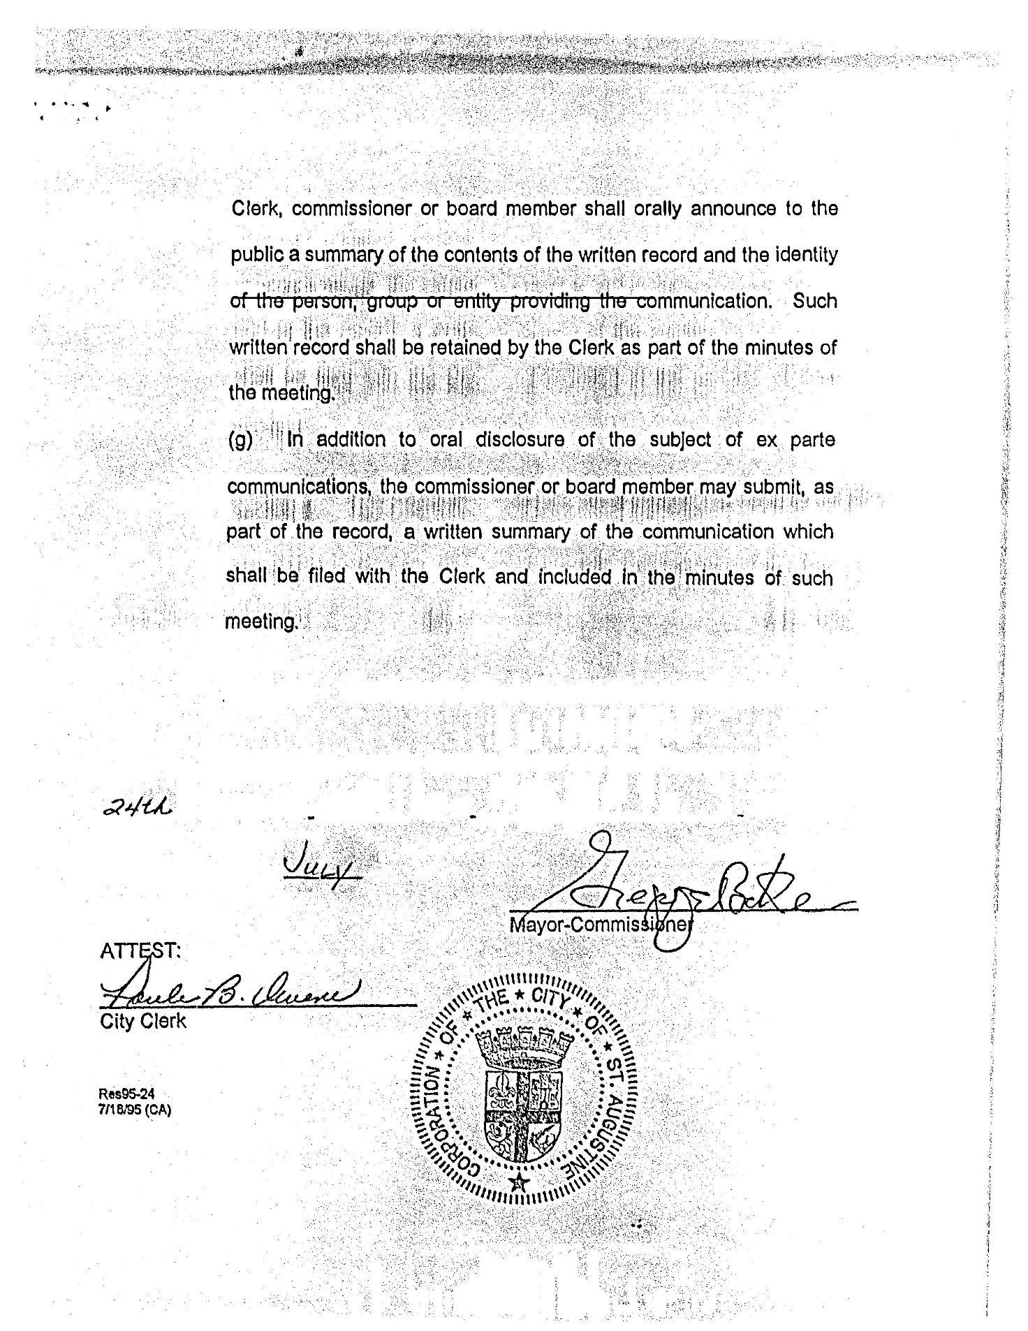

________________________________
Mayor-Commissioner

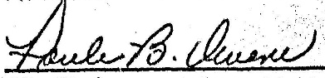
ATTEST:

_____________________________
City Clerk

Res95-24
7/18/95 (CA)

