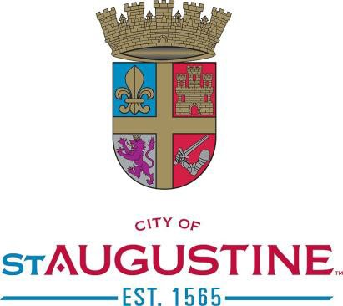

CITY OF ST. AUGUSTINE
AUDIT REVIEW COMMITTEE MEETING
WEDNESDAY, June 11, 2025

1:00 P.M.

COMMUNICATIONS CONFERENCE ROOM (LOBBY B – 2nd FLOOR – CITY HALL)
A G E N D A

- Roll Call

- General Public Comments

- Approval of Minutes (August 20, 2024)

- Review and Approval of the Audit
- Mauldin & Jenkins
- Adjourn
NOTICES: In accordance with Florida Statute 286.0105: “If any person decides to appeal any decision made by the City Commission with respect to any matter considered at this scheduled meeting or hearing, the person will need a record of the proceedings, and for such purpose the person may need to ensure that a verbatim record of the proceedings is made, which record includes the testimony and evidence upon which the appeal is to be based.” In accordance with the Americans with Disabilities Act, persons needing a special accommodation to participate in this proceeding should contact the individual or agency sending notice not later than seven days prior to the proceeding at the address given on the notice. Telephone (904) 825-1007; 1-800-955-8771 (TDB) or 1-800-955-8770 (V), via Florida Relay Service. Please note that one or more members of the City Commission or its appointed boards or committees may attend this meeting and participate, however they may not engage in a discussion or debate amongst themselves on any issue that will likely come before their respective elected or appointed body. The materials prepared and presented are part of the City’s ongoing Florida Public Records and Government in the Sunshine compliance and are not intended to be relied upon or to reach investors or the trading markets.

